**Node Js**

1. Introduction
   1. About node js - **Done**
   2. Where to use node js - **Done**
   3. Why to use node js - **Done**
   4. let, const, var differences - **Done**
   5. Prerequisites
      1. ES-6, ECMAScript
      2. Arrow functions - **Done**
      3. Call back functions
      4. Destructing
      5. Asynchronous - **Inprogress**
      6. Promises
2. Features of node js - **Done**
3. Node js Workflow - **Done**
4. Node js installation - **Done**
5. Best editor (vs code) installation - **Done**
6. Built-in modules in node js
   1. OS Module - **Done**
      1. To get the OS details
         1. type
         2. version
         3. free space
         4. cpu status
      2. To get the current filename and folder name
   2. PATH Module - **Done**
      1. To get the current location where you are now
      2. To get only the file name
      3. To get the extension of the file
      4. To get the current file folder information
   3. FS Module - **Done**
      1. Reading data from file
      2. Creating a new file
      3. Append content to the file
      4. Replace the content in the file
      5. To rename the file
      6. Checking if a file exists or not
      7. Creating a directory
      8. To delete the file
   4. HTTP Module - **Done**
   5. URL Module - **Done**
   6. Events module -
   7. Upload files -
   8. Emails -
7. Local modules or User defined modules - **Done**
8. npm in node js - **Done**
9. Express Js introduction - **Done**
10. Middlewares - **Done**
11. Creating a web server using express js – **Done**

**Introduction**

1. Node js is not a programing language and not a framework and not a library
2. It is a runtime environment used for executing JavaScript code on server side
3. By using this node js, we can develop / build backend services like APIs
4. We can use this APIs with mobile apps and web applications

**Features of Node Js**

1. Node js is for developing a highly scalable, data intensive and real time apps
2. Special features in node js
   1. To use this node js, no need of strongest environment setup
   2. Node is easy to get started. No need of other software’s to run this node js
   3. No need of bigger kind of environmental setup
   4. It is super-fast and highly scalable service
   5. It has a larger eco system of ­­open-source libs. We can develop highly scalable and less weight applications
   6. Javascript everywhere. We can have javascript, where ever we do programming or developing an application. No need-to-know other programming languages

**Node Js Work flow**

1. Node js is an asynchronous by its nature. Asynchronous means it is a non-blocking kind of operations
2. It will take the multiple requests from the multiple users and at the same time and it can handle the response for multiple / all requests. It can handle multiple requests at the same time and it can give response to multiple requests at the same time
3. It will not wait for other process to complete
4. There is no kind of processing one request after completing the other

**Things to work on**

1. ­­HTTP module
2. File system module
3. URL module
4. Node js NPM
5. Node js Email

**Node Js Installation**

1. From website download node js with LTS
   1. <nodejs.org/en>
2. Run the exe file to complete the installation
3. After installation, we can check the version as below
   1. Open command prompt 🡪 Enter command 🡪 node –version

**Best editor to work with node Js**

1. Visual studio code editor

**Hello world program**

1. By using HTTP module, we can able to create a server and we can render the content whatever we want
2. Create one folder for node js application and open this folder with vs code editor
3. Create server.js file in a folder and add below code

var http= require('http');

http.createServer((req,res)=>{

    console.log('Server is running');

    res.write('Hello world');

    res.end();

}).listen('8080');

1. Save the file.
2. To start the server, open the terminal.
3. To run the script, run below command in the terminal
   1. node server.js
4. If we add any console.log statements in the script, then we can see the output in terminal. Otherwise, we need to open the browser and enter the below URL
   1. Localhost:8080

**Explore Hello world program**

1. In the above script, we can use **require** to import the http module
2. To run the server in 8080 port, we use **listen** function, We can use any port which is available
3. In the above script, we use **write** function to generate the content for the browser
4. We need to end the response, so we used **end** function at the end of the arrow function
5. We open the url in the browser, then only server will start and run
6. If we are using node modules, then no need to start and stop the server again and again
7. Whatever we pass the parameters in browser url, we can utilize now using req argument in the server-side script
8. Response can be able to write the content to the particular browser

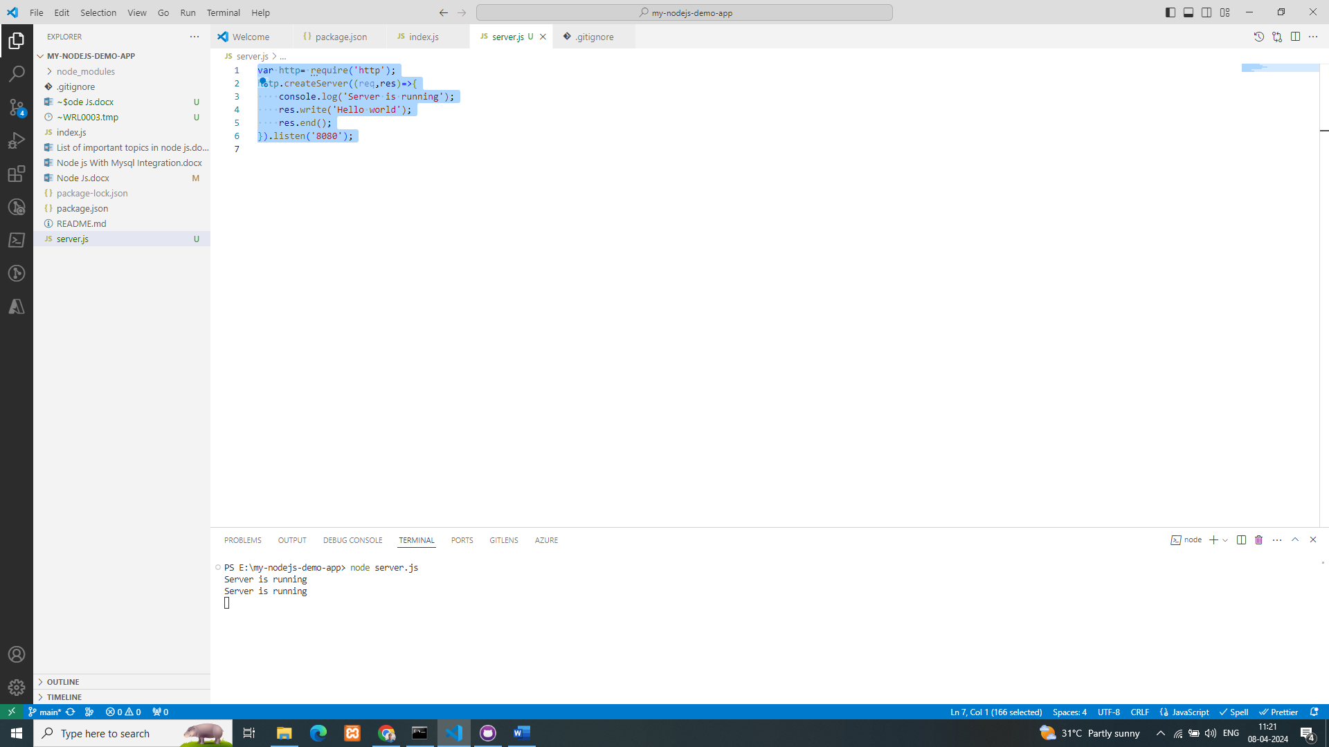

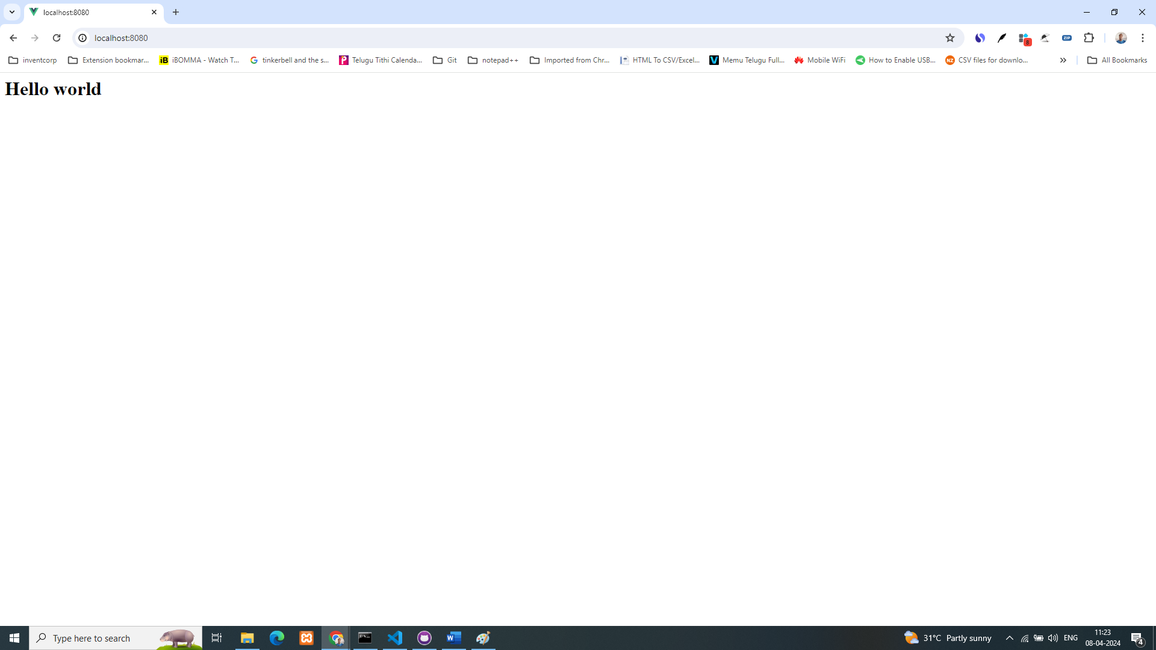

**File system module**

1. To read the file and if you want to display the content in the browser by reading the file at server side, to update the file and to delete the file we use this filesystem module
2. We can shortly call it as fs module and the same use it while writing the script or code
3. To use this module, first we need to import it
4. Script for reading the content from the test.txt file as below

var http= require('http');

var fs = require('fs');

http.createServer((req,res)=>{

    console.log('Server is running');

    // To read the content from the file

    fs.readFile('test.txt',(err,data)=>{

// Here err can be used to handle the errors while reading the file

// Data will store the data after reading the file

        res.write(data);

        res.end();

    })

}).listen('8080');

**URL Module**

1. To handle the URL, parameters and values received from the browser at server side
2. To send the values through params from one page to another page. It might be a path params or that might be a query params
3. To use this URL module, we need to import url module first

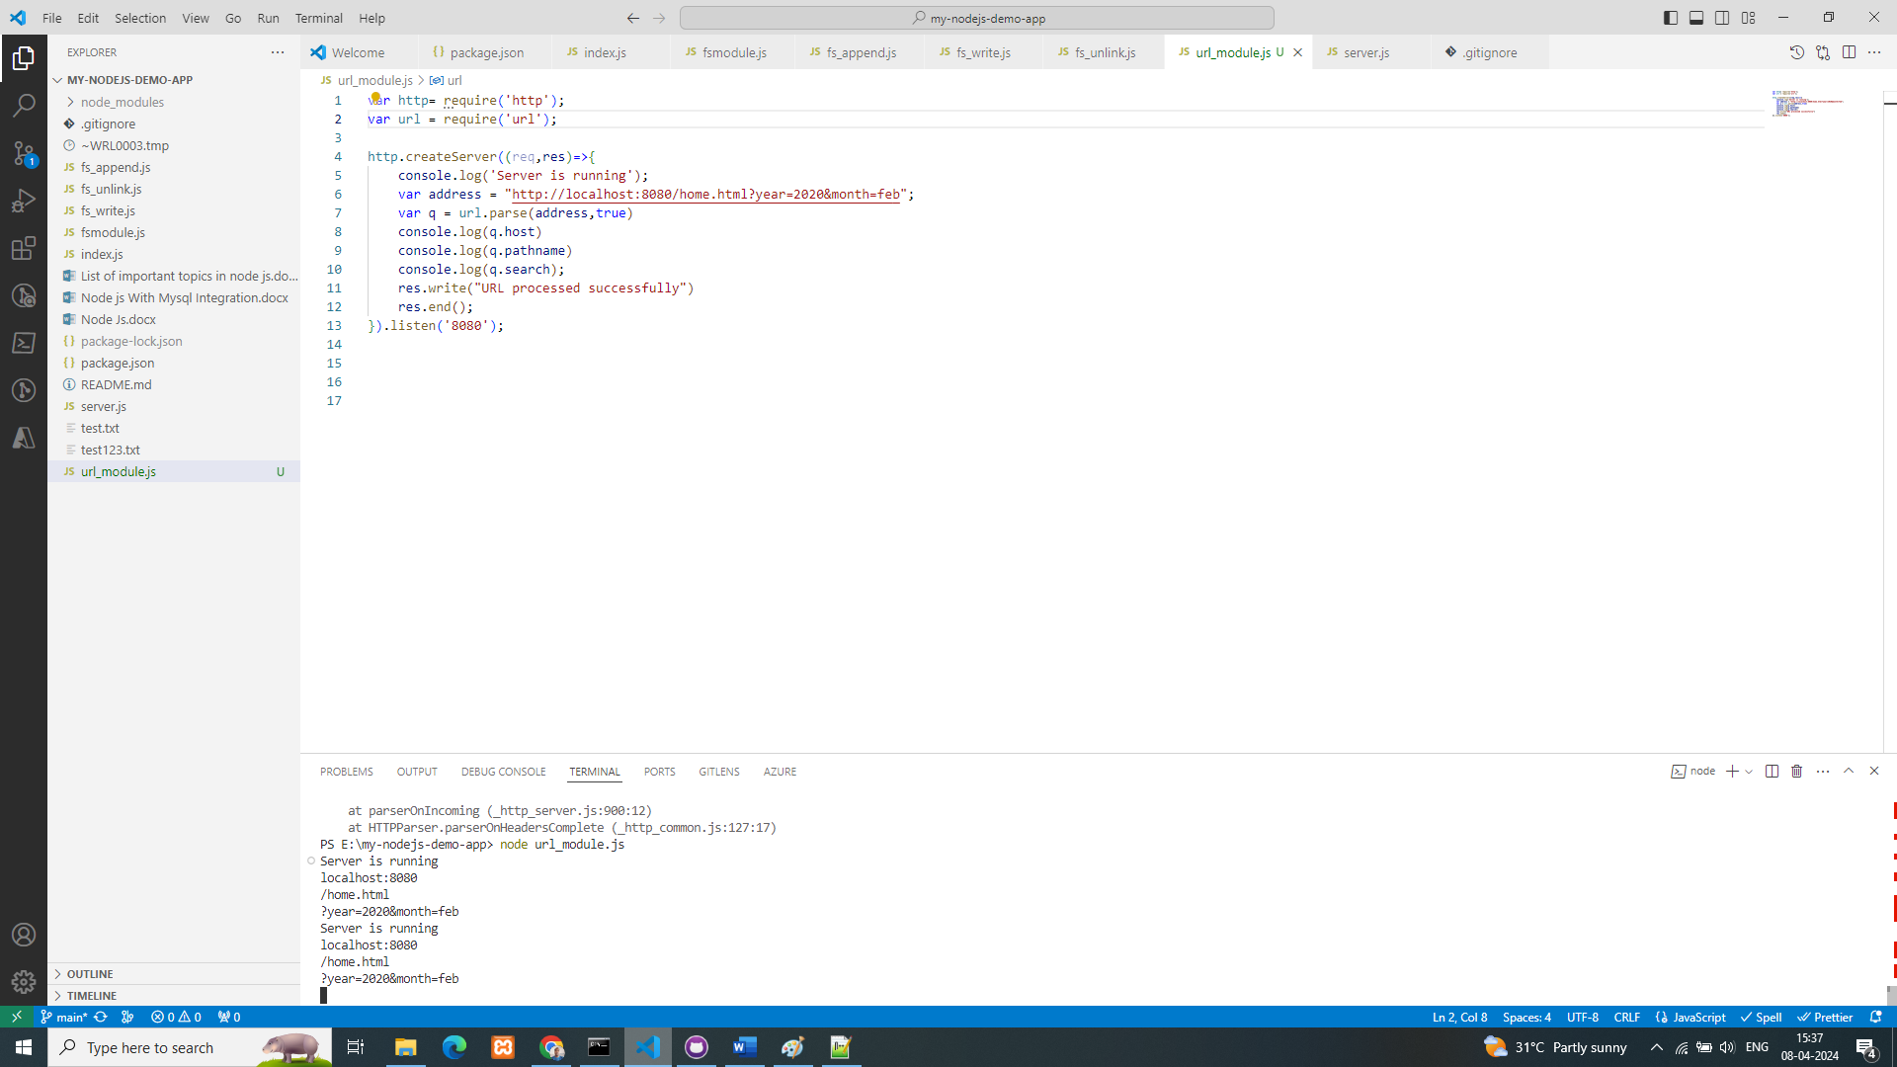

**Node Js NPM Module**

1. NPM stands for node package manager
2. We can perform multiple kind of activities
3. Using this NPM, we can install libraries and utilize them in our real time applications
4. Example: Install upper-case module
   1. Open the command prompt, change the path if required to where we want to install this module using npm and run below command

